**Homework Topic 16 Description**

1. **Image Slider**
2. **Screenshot**

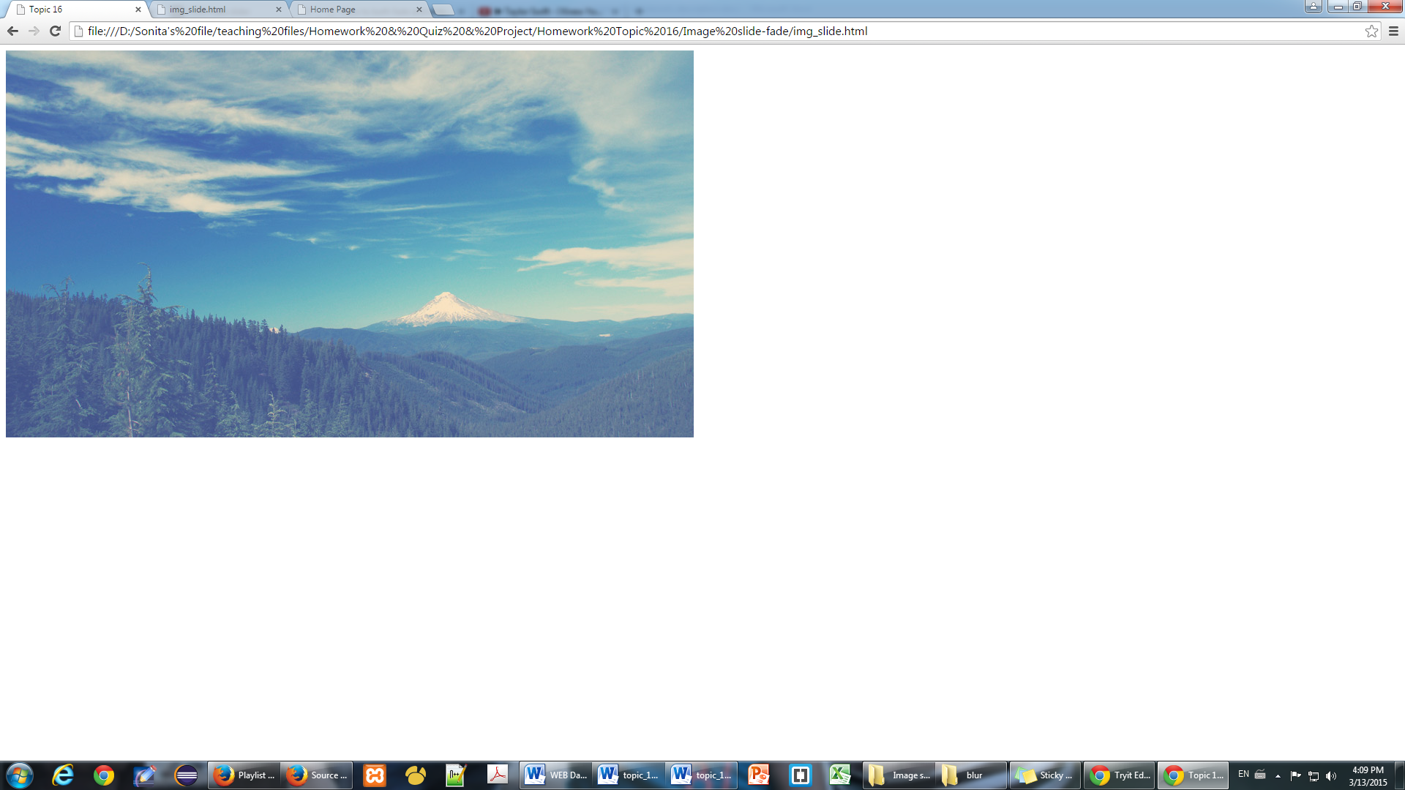

1. **Objective**

After doing this homework, student can create a slide show for their website.

1. **Deadline**

* Start Date: 10/June/2016
* Collection date: 16/June/2016

1. **Instruction**

Using animate() with CSS property, and using callback function() to do this homework.

1. **Marking Criteria**

* Correctness: 80%
* Code Arrangement: 20%

1. **Image Flow**
2. **Screenshot**

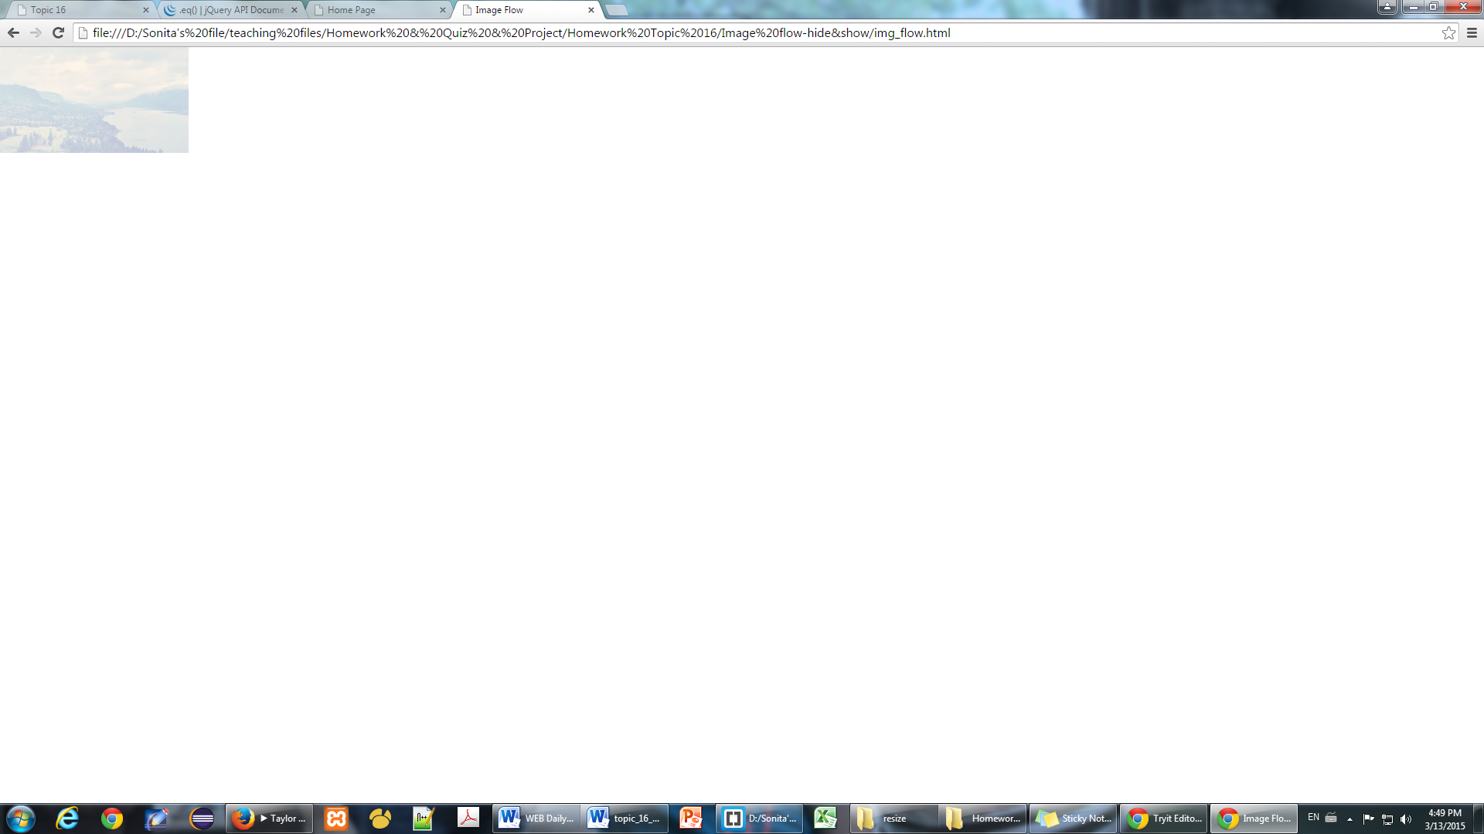

1. **Objective**

Create image flowing and enhance animate() and callback function.

1. **Deadline**

* Start Date: 05/June/2015
* Collection date: 11/June/2015

1. **Instruction**

Using animate and callback function.

1. **Marking Criteria**

* Correctness: 80%
* Code Arrangement: 20%